03. Convolutional Neural Network

- Filter

The following shows the convolution operation for vertical edge detection. The convolution operation is the sum of each element of the first matrix multiplies the related element of the second matrix.
 | * | filter | =
  10 | 10 | 10 | 0 | 0 | 0
  10 | 10 | 10 | 0 | 0 | 0
  10 | 10 | 10 | 0 | 0 | 0
  10 | 10 | 10 | 0 | 0 | 0
  10 | 10 | 10 | 0 | 0 | 0
  10 | 10 | 10 | 0 | 0 | 0
  1 | 0 | -1
  1 | 0 | -1
  1 | 0 | -1
  0 | 30 | 30 | 0
  0 | 30 | 30 | 0
  0 | 30 | 30 | 0
  0 | 30 | 30 | 0

The following shows the dimensions of the matrix and filter.
$$n×n * f×f = (n-f+1)×(n-f+1)$$

Padding: Padding allows you to use a convolution layer without shrinking the height and width of the volumes. It also allows to keep more information at the edge of the image. The Same Convolution pads $\left(f-1\right) / 2$ cells to the original matrix so that the output size is the same as the input size.
$$n×n * f×f = n×n$$

Stride: Strided convolution moves more than one cell in each step. Given padding = p and stride = s, we have
$$n×n * f×f = \left\lfloor (\frac{n+2p-f}{s}+1)\right\rfloor ×\left\lfloor (\frac{n+2p-f}{s}+1)\right\rfloor$$

Channel: The input and the filter can have multiple channels. For example, an RGB image is a volume with 3 channels. Each filter must have the same number of channels as the volume.

Multiple Filters: We can apply multiple filters on a volume. The number of output channels equal to the number of filters. The following supposes that there is no padding and stride is 1.
$$n×n×n_{c} * f×f×n_{c} = (n-f+1)×(n-f+1)×f_{c}$$

- Convolutional Neural Network (CNN)

The following shows the notations for layer $l$.
- $f^{[l]}$ : filter size,
- $p^{[l]}$ : padding size,
- $s^{[l]}$ : stride,
- $n_{C}^{[l]}$ : the number of filters,
- Input: $n_{H}^{[l-1]}×n_{W}^{[l-1]}×n_{C}^{[l-1]}$ (height, weight, channel).

Since the filters must have the same number of channels as the input, the dimension of each filter is:
$$f^{[l]}×f^{[l]}×n_{C}^{[l-1]}$$

The number of output channels equals to the number of filters, so the dimension of the output is:
$$n_{H}^{[l]}×n_{W}^{[l]}×n_{C}^{[l]}, where n_{H}^{[l]}=\left\lfloor \frac{n_{H}^{[l-1]}+2p^{[l]}-f^{[l]}}{s^{[l]}}+1\right\rfloor , n_{W}^{[l]}=\left\lfloor \frac{n_{W}^{[l-1]}+2p^{[l]}-f^{[l]}}{s^{[l]}}+1\right\rfloor$$

Therefore, for layer $l$, the dimension of the activation is:
$$A^{[l]}→m×n_{H}^{[l]}×n_{W}^{[l]}×n_{C}^{[l]}$$

The dimension of the weights is:
$$W=f^{[l]}×f^{[l]}×n_{C}^{[l-1]}×n_{C}^{[l]}$$

Each filter has a single bias, so the dimension of the bias is:
$b=(1, 1, 1, n_{C}^{\left[l\right]})$

The following shows an example of ConvNet.
Input $x$ | $--→$ | $$a^{[1]}$$ | $--→$ | $$a^{[3]}$$ | $--→$ | $$a^{[3]}$$ | Unrolled to a  vector [1960, 1]
39, 39, 3 | $$f^{[1]}=3$$  $$s^{[1]}=1$$  $$n_{C}^{[1]}=10$$ | 37, 37, 10 | $$f^{[2]}=5$$  $$s^{[2]}=2$$  $$n_{C}^{[2]}=20$$ | 17, 17, 20 | $$f^{[3]}=5$$  $$s^{[3]}=2$$  $$n_{C}^{[3]}=40$$ | 7, 7, 40 | $$\left[\begin{aligned}\begin{aligned}\begin{aligned}O \\ O\end{aligned} \\ ⋮\end{aligned} \\ O\end{aligned}\right]→O→y$$

Given $A^{[l-1]}, W^{[l]}, b^{[l]}, {stride}^{[l]}, {pad}^{[l]}$, the following shows how to compute $A^{[l]}$ using forward propagation.
- Compute $n_{H}^{[l]}$ and $n_{W}^{[l]}$.
- Add paddings $A_{pad}^{ [l-1]}=pad(A^{[l-1]})$.
- For $i=1 to m:$ (for each example)
For $j=1 to n_{C}^{[l]}:$ (for each filter)
For each cube $A_{cube}$ of $A_{pad}^{ [l-1]}$: (each cube has the shape as $W^{[l]}$, which is $f^{[l]}×f^{[l]}×n_{C}^{[l-1]}$)
$$Z^{[l]}=\sum_{cube}{W^{[l]} .* A_{cube}}+b^{[l]} (elementwise multiply)$$
$$A^{[l]}=g(Z^{[l]})$$

- Pooling Layer

In a convolutional network, there are three types of layers: convolution, pooling, and fully connected. ConvNets use pooling layers to reduce the size of the representation to speed up the computation. There are no filters in a pooling layer, and so there are no parameters to learn. It is just a fixed computation. The number of output channels equal to the number of input channels $(n_{C}^{\left[l\right]}=n_{C}^{\left[l-1\right]})$. In a max pooling, it just takes the maximum value from each region. In an average pooling, it just takes the average value from each region. The pooling layers usually have a filter size of 2 and stride = 2.
 | $$--→$$  $$f=2$$  $$s=2$$
  1 | 3 | 2 | 1
  2 | 9 | 1 | 1
  1 | 3 | 2 | 3
  5 | 6 | 1 | 2
  9 | 2
  6 | 3

Given $A^{[l-1]}, {stride}^{[l]}, {pad}^{[l]}$, the following shows how to compute $A^{[l]}$ using forward propagation.
- Compute $n_{H}^{[l]}$ and $n_{W}^{[l]}$.
- For $i=1 to m:$ (for each example)
For $j=1 to n_{C}^{[l]}:$ (for each channel of input, $n_{C}^{\left[l\right]}=n_{C}^{\left[l-1\right]}$)
For each square $A_{part}$ of $A^{[l-1]}$ (for each square with $f×f)$ )
$A^{[l]}=max⁡(A_{part})$ (max pooling)
$A^{[l]}=mean⁡(A_{part})$ (average pooling)

A fully connected layer is just a classic layer in which m nodes fully connect to n nodes. In a neural network, the common pattern is first it has one or more convolution layers followed by a pooling layer, and then one or more convolution layers followed by a pooling layer. At the end it has a few fully connected layers, and then followed by a softmax.

The following shows an example of neural network (padding = 0).
Input $x$ |  | $--→$ |  | Conv 1 | $--→$ |  |  | Pool 1 | $--→$ |  |  | Conv 2 |  | $$--→$$ | Pool 2
32, 32, 3 |  | $f=5$  $s=1$  $n_{C}=8$ |  | 28, 28, 8 | $$f=2$$  $$s=2$$ |  |  | 14, 14, 8 | $$f=5$$  $$s=1$$  $$n_{C}=16$$ |  |  | 10, 10, 16 |  | $$f=2$$  $$s=2$$ | 5, 5, 16
$--→$ | vector |  | $--→$ |  |  | FC 3 | $--→$ |  |  | FC 4 | $$--→$$ |  | Softmax
Flatten to  a vector | 400, 1 |  | Fully connected |  |  | 120, 1 | Fully connected |  |  | 84, 1 |  |  | For example  10 outputs

As it goes deeper in the neural network, usually the heights and widths will decrease, whereas the number of channels will increase. Usually convolution layers have relatively few parameters, pooling layers have no parameters, and a lot of parameters tend to be in the fully connected layers. Additionally, the activation size tends to go down gradually.

Give a convolution layer with $n_{C}^{[l]}$ filters which are $f×f×n_{C}^{[l-1]}$, the number of parameters is (1 is bias):
$$\left(f∙f∙n_{C}^{\left[l-1\right]}+1\right)∙n_{C}^{\left[l\right]}$$

Example:
 | Activation shape | Activation size | # Parameters
Input | (32, 32, 3) | 3072 | 0
CONV 1 | (28, 28, 8) | 6272 | 608 = (5 * 5 * 3 + 1) * 8
POOL 1 | (14, 14, 8) | 1568 | 0
CONV 2 | (10, 10, 16) | 1600 | 3216 = (5 * 5 * 8 + 1) * 16
POOL 2 | (5, 5, 16) | 400 | 0
FC 3 | (120, 1) | 120 | 48120 = 400 * 120 + 120
FC 4 | (84, 1) | 84 | 10164 = 120 * 84 + 84
Softmax | (10, 1) | 10 | 850 = 84 * 10 + 10

Convolution network has the following features.
- Parameter sharing. A feature detector that is useful in one part of the image is probably useful in another part.
- Sparsity of connections. In each layer, each output value depends only on a small number of inputs.

In this way, convolution network reduces the total number of parameters, thus reducing overfitting.

- Convolutional Layer Backpropagation (optional)

In modern deep learning frameworks, you only have to implement the forward pass, and the framework takes care of the backward pass, so most deep learning engineers don't need to bother with the details of the backward pass.

Given $A^{[l-1]}, W^{[l]}, b^{[l]}, {stride}^{[l]}, {pad}^{[l]}, {dZ}^{[l]}$, the following computes ${dW}^{[l]}, {db}^{[l]}, {dA}^{[l-1]}$ using backpropagation.
- For $i=1 to m:$ (for each example)
Add paddings $A_{pad}^{ [l-1]}=pad(A^{\left[l-1\right]})$
For $j=1 to n_{C}^{[l]}:$ (for each channel)
For each cube $A_{cube}$ of $A_{pad}^{ [l-1]}$ (for each cube)
$${dA}_{pad}^{ [l-1]} ={dA}_{pad}^{ [l-1]}+\sum_{h=0}^{n_{H}}{\sum_{w=0}^{n_{W}}{W_{c}×{dZ}_{hw}}}$$
$${dW}_{c}={dW}_{c}+\sum_{h=0}^{n_{H}}{\sum_{w=0}^{n_{W}}{A_{cube}×{dZ}_{hw}}}$$
$$db=\sum_{h=0}^{n_{H}}{\sum_{w=0}^{n_{W}}{{dZ}_{hw}}}$$
Extract ${dA}^{\left[l-1\right]}$ from ${dA}_{pad}^{ [l-1]}$.

- Pooling Layer Backpropagation (optional)

Given $A^{[l-1]}, {stride}^{[l]}, f^{[l]}, {dA}^{[l]}$, the following computes ${dA}^{[l-1]}$ using backpropagation.
- For $i=1 to m:$ (for each example)
For $j=1 to n_{C}^{[l]}:$ (for each channel)
For each square ${dA}_{i,j,h,w}$ of ${dA}^{[l]}$ (for each square)
${dA}_{i, j,h,w}^{ [l-1]} =mask*{dA}_{i, j,h,w}$ (max pooling)
${dA}_{i, j,h,w}^{ [l-1]} =convert({dA}_{i, j,h,w})$ (average pooling)

The following shows how to generate the mask for max pooling.
$$\left[ \begin{matrix}0 & 0 \\ 1 & 0\end{matrix} \right] ⟵ \left[ \begin{matrix}1 & 5 \\ 9 & 3\end{matrix} \right]$$

The following shows how to convert average pooling.
$$\left[ \begin{matrix}3/4 & 3/4 \\ 3/4 & 3/4\end{matrix} \right] ⟵ 3$$

- CNN and TensorFlow

Given a CNN as below:
Conv2d -> ReLU -> Max Pool -> Conv2d -> ReLU -> Max Pool -> Flatten -> Fully-Connected.

The following shows how to implement forward propagation using TensorFlow.

def forward_propagation(X, W1, W2):

Z1 = tf.nn.conv2d(X, W1, strides=[1, 1, 1, 1], padding='SAME')
A1 = tf.nn.relu(Z1)
P1 = tf.nn.max_pool(A1, ksize=[1, 8, 8, 1], strides=[1, 8, 8, 1], padding='SAME')

Z2 = tf.nn.conv2d(P1, W2, strides=[1, 1, 1, 1], padding='SAME')
A2 = tf.nn.relu(Z2)
P2 = tf.nn.max_pool(A2, ksize=[1, 4, 4, 1], strides=[1, 4, 4, 1], padding='SAME')

F = tf.contrib.layers.flatten(P2)
Z3 = tf.contrib.layers.fully_connected(F, 6, activation_fn=None)

return Z3

The following shows how to implement Mini-Batch Gradient Descent using TensorFlow.

def model(X_train, Y_train, X_test, Y_test, learning_rate, epochs, minibatch_size):

W1 = tf.get_variable("W1", [4, 4, 3, 8], tf.contrib.layers.xavier_initializer(seed = 0))
W2 = tf.get_variable("W2", [2, 2, 8, 16], tf.contrib.layers.xavier_initializer(seed = 0))

for epoch in range(epochs):
cost = 0
batches = int(m / batch_size)

for minibatch in minibatches:
(miniX, miniY) = minibatch

Z3 = forward_propagation(miniX, W1, W2)
temp_cost = tf.reduce_mean(tf.nn.softmax_cross_entropy_with_logits(Z3, miniY))
cost += temp_cost / batches

print(cost)

- Residual Network (ResNet)

Very deep neural networks are difficult to train because of vanishing and exploding gradient problems. In a ResNet, a "shortcut" or "skip connection" allows the model to skip layers. The following shows a ResNet block. By stacking these ResNet blocks on top of each other, you can form a very deep network.
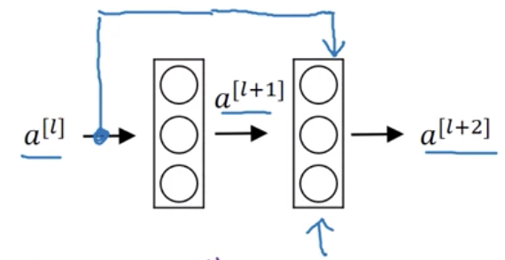

In an identity block of a ResNet, the input activation $a^{[l-1]}$ has the same dimensions as the output activation $a^{[l]}$.

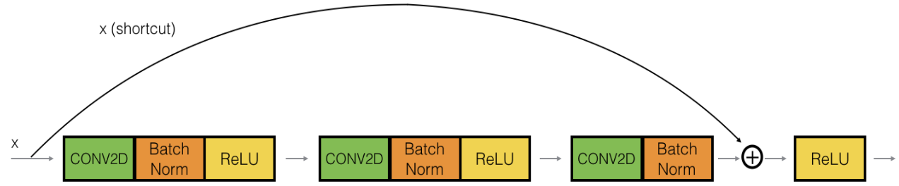

The following shows how to create the identity block above.

# filters: a list of integers specifying the number of filters
# f: an integer specifying the shape of the filter

def identity_block(X, f, filters):

F1, F2, F3 = filters
X_shortcut = X

# First component of main path: filters is the number of filters
X = Conv2D(filters = F1, kernel_size = (1, 1), strides = (1, 1), padding = 'valid')(X)
X = BatchNormalization(axis = 3)(X)
X = Activation('relu')(X)

# Second component of main path: kernel_size is the shape of the filter
X = Conv2D(filters = F2, kernel_size = (f, f), strides = (1, 1), padding = 'same')(X)
X = BatchNormalization(axis = 3)(X)
X = Activation('relu')(X)

# Third component of main path
X = Conv2D(filters = F3, kernel_size = (1, 1), strides = (1, 1), padding = 'valid')(X)
X = BatchNormalization(axis = 3)(X)

# Final step: Add shortcut value to main path
X = Add()([X_shortcut, X])
X = Activation('relu')(X)

return X

In a convolutional block of a ResNet, the input activation $x$ has different dimensions from the output activation $a^{[l]}$. A convolution layer (without any non-linear function) is added to the shortcut path to reduce the dimension of the input in order to match the dimension of the output.

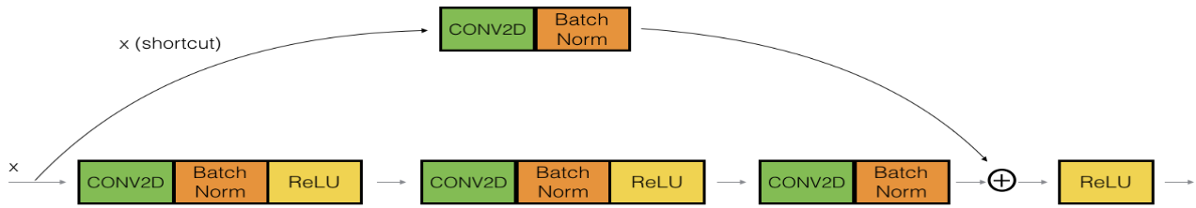

The following shows how to create the identity block above.

def convolutional_block(X, f, filters, s = 2):

F1, F2, F3 = filters
X_shortcut = X

# First component of main path
X = Conv2D(F1, (1, 1), strides = (s, s), padding = 'valid')(X)
X = BatchNormalization(axis = 3)(X)
X = Activation('relu')(X)

# Second component of main path
X = Conv2D(F2, (f, f), strides = (1, 1), padding = 'same')(X)
X = BatchNormalization(axis = 3)(X)
X = Activation('relu')(X)

# Third component of main path
X = Conv2D(F3, (1, 1), strides = (1, 1), padding = 'valid')(X)
X = BatchNormalization(axis = 3)(X)

# Shortcut path
X_shortcut = Conv2D(F3, (1, 1), strides = (s, s), padding = 'valid')(X_shortcut)
X_shortcut = BatchNormalization(axis = 3)(X_shortcut)

# Final step: Add shortcut value to main path
X = Add()([X_shortcut, X])
X = Activation('relu')(X)

return X

The following shows a 50-layer deep ResNet built using the blocks above. "ID BLOCK × 3" means that three identity blocks stack together. "CONV BLOCK" means a convolutional block.

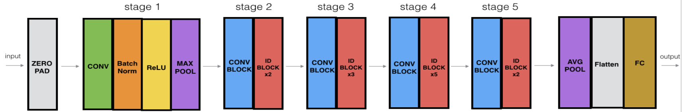

The following creates a model.

def ResNet50(input_shape = (64, 64, 3), classes = 6):

X_input = Input(input_shape)

# Zero-Padding
X = ZeroPadding2D((3, 3))(X_input)

# Stage 1
X = Conv2D(64, (7, 7), strides = (2, 2), kernel_initializer = glorot_uniform(seed=0))(X)
X = BatchNormalization(axis = 3)(X)
X = Activation('relu')(X)
X = MaxPooling2D((3, 3), strides = (2, 2))(X)

# Stage 2
X = convolutional_block(X, f = 3, filters = [64, 64, 256], s = 1)
X = identity_block(X, 3, [64, 64, 256])
X = identity_block(X, 3, [64, 64, 256])

# Stage 3
X = convolutional_block(X, f = 3, filters = [128, 128, 512], s = 2)
X = identity_block(X, 3, [128, 128, 512])
X = identity_block(X, 3, [128, 128, 512])
X = identity_block(X, 3, [128, 128, 512])

# Stage 4
X = convolutional_block(X, f = 3, filters = [256, 256, 1024], s = 2)
X = identity_block(X, 3, [256, 256, 1024])
X = identity_block(X, 3, [256, 256, 1024])
X = identity_block(X, 3, [256, 256, 1024])
X = identity_block(X, 3, [256, 256, 1024])
X = identity_block(X, 3, [256, 256, 1024])

# Stage 5
X = convolutional_block(X, f = 3, filters = [512, 512, 2048], s = 2)
X = identity_block(X, 3, [512, 512, 2048])
X = identity_block(X, 3, [512, 512, 2048])

# AVGPOOL
X = AveragePooling2D(pool_size = (2, 2))(X)

# output layer
X = Flatten()(X)
X = Dense(classes, activation='softmax', kernel_initializer = glorot_uniform(seed=0))(X)

model = Model(inputs = X_input, outputs = X, name = 'ResNet50')
return model

The following compiles and trains the model.

model = ResNet50(input_shape = (64, 64, 3), classes = 6)
model.compile(optimizer='adam', loss='categorical_crossentropy', metrics=['accuracy'])

model.fit(X_train, Y_train, epochs = 20, batch_size = 32)

preds = model.evaluate(X_test, Y_test)

print ("Loss = " + str(preds[0]))
print ("Test Accuracy = " + str(preds[1]))

- Inception Network

If you are building a layer of a neural network and you don't know what size of the filter to use, you can use multiple filters with different sizes and concatenate the results. This is called inception network.

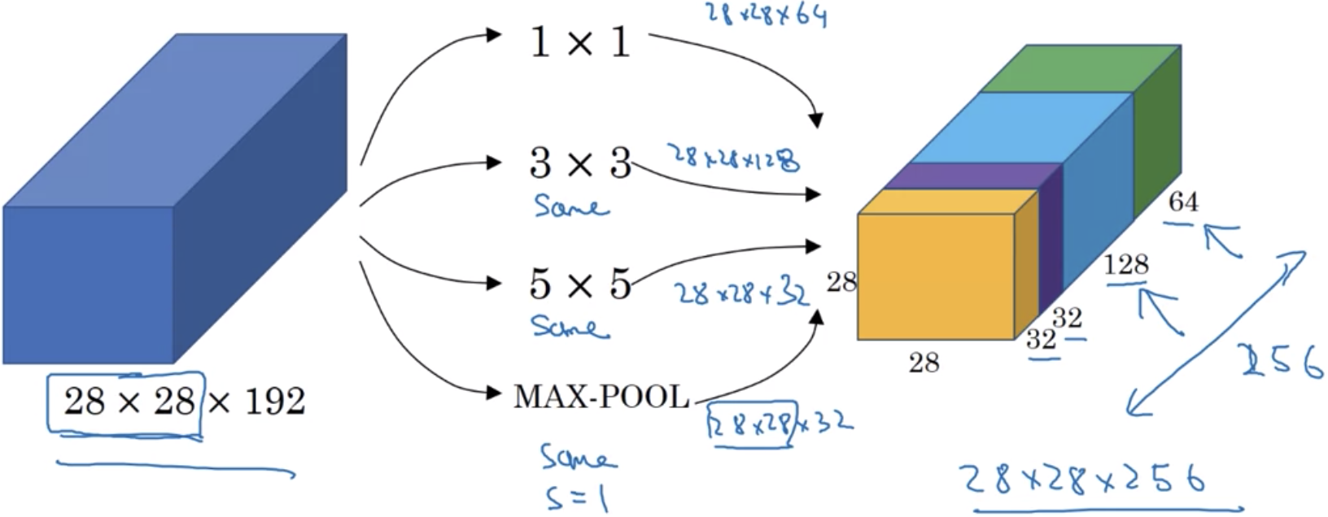

It may take longer to train an inception network. The $1×1$ convolutions are used to reduce the computational cost of the inception network. The following shows an inception module.

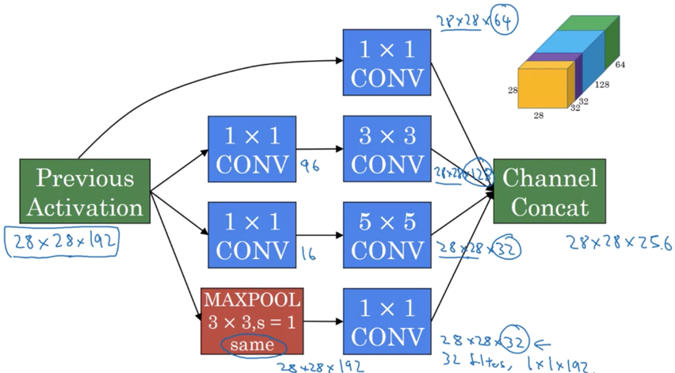

The $1×1$ convolution layer adds non-linearity (the ReLU function) to the neural network and allows you to shrink (or keep same, or increase) the number of channels.

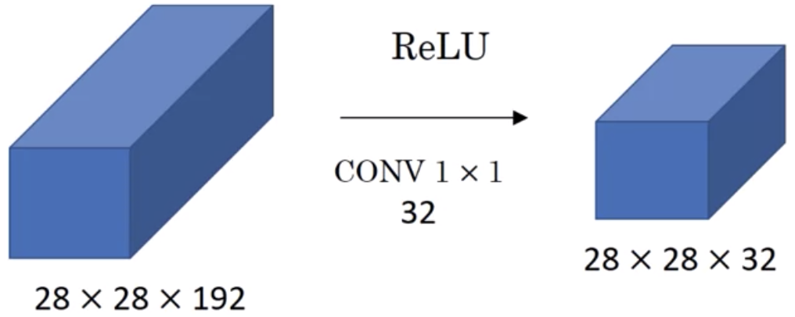

The following shows an inception network.

